**Final Data Extraction & Processing Roadmap**

* *Roadmap outlines the steps we have taken to obtain the final dataset “****Final data_9April****”*

**Step 1: Obtain icustays for cancer patients without HF** **(Table 1)**

* + Merge icustay table with diagnoses_icd table, filter records for cancer patients without HF

|  |  |
| --- | --- |
| Find cancer patients | - ICD code 9: 140 – 239;  - ICD code 10: C00-C97 |
| Remove patients with HF | - ICD code 9: 428;  - ICD code 10: I50 |

* Step 2: **Keep labevents for ICU cancer patients without HF who have their troponin levels measured during ICU stay**

1. Obtain relevant labevents for ICU cancer patients withou HF
   * + Inner join labevnts table and table 1 on hadm_id and remove records if icu_stay ISNULL
     + Only keep records with relevant lab tests in labevents table

**Itemids for required lab tests:**

|  |  |
| --- | --- |
| Troponin I | 51002, 52642 |
| Troponin T | 51003 |
| NTproBNP | 50963 |
| proBNP, Pleural | 51921 |

*\* BNP information was extracted but not used in our analysis*

1. Keep labevents if measured during ICU stay
   * + Keep rows if labevents charttime between
     + Lab tests measured during ICU stay is defined as:
       1. **charttime in labevents** table BETWEEN **icustays intime & outtime**
     + Table 3 contains information for ICU cancer patients (without HF) who have their troponin/BNP/nt-proBNP levels measured during ICU stay

* Step 4: **Include patient demographics information**
  + Merge with core.patients table on subject_id
* Step 5: **Data processing using Python –** merge multiple Troponin tests for the same patient during the same ICU stay
  + Add new columns for each lab test respectively (51002, 52642, 51003, 50963, 51921) such that each row represents one unique ICU admission
  + Add one additional column for the Maximum Troponin measured during ICU stay
* Step 6: **Additional features added for PSM**

1) patient admission weight from ICU_chartevents (itemid226512)

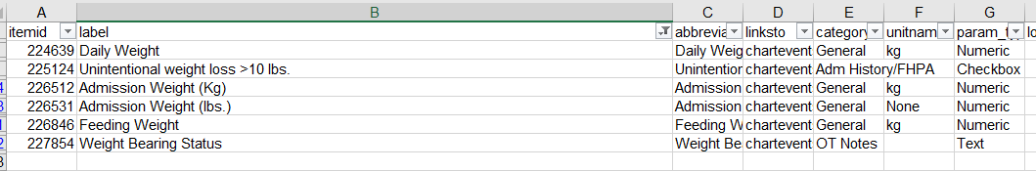

2) Patient creatinine labtest (from hosp-lab events)

* hosp-lab events
* —creatinine <=1.4mg/dL (normal)
* —creatinine >1.4mg/dL (abnormal)

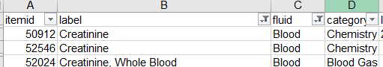

3) Other Diagnoses

- Binary features to indicate whether patients have a disease

* hosp-[diagnoses_icd](https://mimic.mit.edu/docs/iv/modules/hosp/diagnoses_icd/) (Categorization)
* —hypertension (ICD9-401,401.1,401.9; ICD10-I10)
* —diabetes(ICD9–250,ICD10-E08-13)

Acute myocardial infarction (ICD-9/ICD-9-CM: **410**; or ICD-10-CA: I21, I22) ischemic heart disease (ICD-9/ICD-9-CM: **414.9**; or ICD-10-CA: I21, I22)

* —Chronic kidney disease(ICD9–585.9,ICD10-N18.9)
* —COPD(ICD9.0-490-496; ICD10-J44.9)
* --Atrial fibrillation (ICD9.0-**427.31**; ICD10-I48)
* —chronic ischaemic heart disease and other forms of acute ischaemic heart disease(ICD9.0-414.9;ICD10-**I24.** **8)**
* —CEREBROVASCULAR DISEASE( ICD9-430-438,ICD10-**I67.** **9)**
* Step 7: **Add statin exposure information using Python**

1) Keep ONLY the first ICU stay for each patient

* Sort by patient id and ICU_in_time in ascending order. Keep only the ICU stay

2) Add hospital admission time based on hospital admission ID and first Troponin measured during hospitalization

3) Add extracted Statin information

**Statin mapping using GSN codes:**

|  |  |  |  |  |  |  |  |
| --- | --- | --- | --- | --- | --- | --- | --- |
| **Statin (active ingredient)** | **Statin (brand name)** | **GSN** | | | | | **Combined** |
| Atorvastatin | Lipitor | 029967 | 029968 | 029969 | 045772 |  | '029967','029968','029969','045772' |
| Ezetimibe/simvastatin | Vytorin |  |  |  |  |  |  |
| Fluvastatin | Lescol XL | 021694 | 046757 |  |  |  | '021694','046757' |
| Lovastatin | Altoprev | 006460 | 006461 | 016310 |  |  | '006460','006461','016310', |
| Pitavastatin | Livalo | 066349 | 066350 | 066351 |  |  | '066349','066350' |
| Pravastatin | Pravachol | 016367 | 016366 | 020741 | 049758 |  | '016367','016366','020741','049758' |
| Rosuvastatin | Ezallor | 051785 | 052944 | 051784 | 051786 |  | '051785','052944','051784','051786' |
| Simvastatin | FloLipid | 016577 | 016579 | 040238 | 016576 | 016578 | '016577','016579','040238','016576','016578' |

4) **Statin exposure definition:**

*\*\*Statin exposure is based on patient hospital stay rather than ICU stay as patients might receive statins prior to ICU admission….*

* 1. **Group 0** (No statin exposure) → Patients who have not been prescribed with statin during the current ICU stay (hence hospitalization) and all previous hospitalizations
  2. **Group 1 (**Withstatin exposure)**:**
     1. Patients without statin rx during the current hospitalization, but have been prescribed with statins in previous hospitalizations
     2. Patients with statin prescribed within 24 hours of hospital admission and first troponin (during hospitalization) measured 48 hours after hospital admission (Definition 1)
  3. **Group 2:** 
     1. Patients received statin during current hospitalization (excluding Group 1). HOWEVER, statins might be prescribed before, during or after ICU stay.
        + Group 1 → Patients did not qualify under Definition 1 for Group 0, but they have statin prescribed in previous hospitalization